Current Market View – April 2026

Investment Markets
Global Markets
Global markets in April 2026 were defined by a powerful rebound in risk appetite, with equities surging despite persistent geopolitical tensions and elevated energy prices. A fragile ceasefire in the Middle East helped steady sentiment even as disruptions in the Strait of Hormuz kept oil above USD 90–110 per barrel. Investors largely looked through these risks, focusing instead on the US reporting season. The Emerging markets, particularly Taiwan and South Korea, delivered exceptional gains as AI‑linked semiconductor stocks rallied sharply. Growth stocks outperformed value, and global equities overall posted returns near 10%, reflecting renewed confidence in the AI investment cycle and robust earnings momentum.
Fixed-income markets were more mixed. Elevated oil prices and persistent inflation pressures kept government bond yields volatile, limiting gains in sovereign debt. Commodities delivered positive returns overall, with energy and industrial metals outperforming amid supply concerns and strong demand tied to global data centre build-outs. Meanwhile, macroeconomic data showed steady momentum as US GDP grew 2.0% annualised in Q1, inflation ticked higher due to energy costs, and labour markets remained resilient. Emerging markets benefited from a weaker US dollar and renewed appetite for higher-risk assets, while developed markets advanced on improving business sentiment and strong earnings. Overall, April 2026 marked a month in which markets demonstrated surprising resilience, rallying amid geopolitical uncertainty and reaffirming the dominance of technology-driven growth themes.
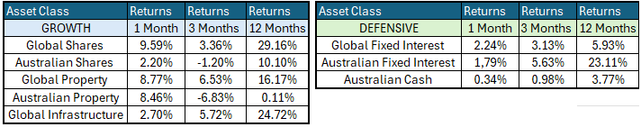

Global Share Markets
Global share markets rebounded in April after the brief sell-off in March, when investors sold down just about everything except oil and gas stocks profiting from higher prices amid the closure of the Strait of Hormuz. ExxonMobil is still leading year to date, but the stars in April were the US tech/AI giants, underpinned by very good profit reports for the March quarter (Microsoft, Amazon, Alphabet/Google, although Facebook was not as strong). Outside the global/US giants, cyclical sectors like industrials, materials, and financials did well in April, with good price gains across the board.
March saw developed markets underperform Asian and U.S. markets, with Asian economies rebounding from their sell-off last month. Within European equities, the United Kingdom and Switzerland were the weakest performers due to limited or no large technology exposure in their markets.
The Australian share market lagged the United States and the rest of the world, with the domestic market having limited exposure to technology companies. The threat of AI has impacted the Australian technology sector, as global technology names look to disintermediate our local players with AI.
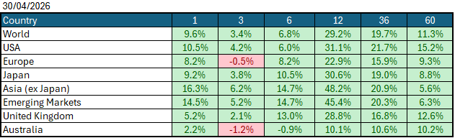
Data Source: AFM as of April 30, 2026.

Global Bond Markets
Bond markets posted losses as yields worldwide rose amid continued concern over the war in Iran, raising the risk of higher, stickier inflation and higher global interest rates. Bond investors are now starting to price in elevated interest rates globally, as governments may come under pressure to run fiscal deficits amid a global slowdown. Over the month, credit spreads widened from very tight levels as investors sought to move assets into more "safe harbour" assets.
Interest rate markets in the U.S. and the UK rose in April 2026, with the 10-year Government bond rate rising to 4.4072%. UK 10-year Gilts were trading at 5.283% on April 30 2026.
Domestic Bond Markets
Treasury yields rose across all maturities in Australia as markets continue to price in rate hikes and stickier inflation. In Australia, the latest inflation print for March 2026 (year-on-year) increased to 4.6%, up from 3.7% in February. The RBA board is set to meet on the 4th/5th May 2026, with the market fully pricing in a +25bps rate hike to 4.35%.

Investment Climate
U.S. equities posted a strong performance in April 2026 as the earnings season benefited from strong results from mega-cap AI infrastructure companies, which posted strong revenue growth in the cloud and data centre segments. Semiconductor manufacturers extended their dominance as the backbone of the AI cycle, with record shipments of advanced GPUs and custom accelerators pushing margins higher and widening the gap between leading-edge and legacy chipmakers. Software and platform companies also benefited, reporting accelerating adoption of AI-enhanced productivity tools and subscription upgrades that lifted recurring revenue.
Over the medium term, investors are encouraged by the anticipated productivity benefits from AI and the hyperscalers' investments in AI. However, with the unsettled nature of the bond markets due to the war in Iran, the short term has put the handbrake on the level of encouragement. If the US changes its tone and begins raising interest rates under its new Federal Chairman, Kevin Warsh, the medium term could become much less encouraging.
Long-term investors are cautiously optimistic about a recovery period ahead. Global central banks continue to signal their resolve to bring inflation under control; however, economic data show signs of stabilisation despite elevated inflation, which could prompt central banks to raise interest rates in 2026.
The following commentary is based on month-end closing prices as of April 30, 2026:
Global share markets were stronger in April, driven by investor optimism that geopolitical events in the Middle East will come to an end soon, with US and Asian markets outperforming Europe and the United Kingdom, which has less access to AI technology companies. The AUD/USD strengthened from 0.6900 to 0.7201 (+4.4%).
The U.S. Fed held the federal funds rate target range at 3.50%-3.75% at its meeting on the 28th/29th April 2026. Last month, the rhetoric of a soft landing came under pressure amid the expected rise in inflation following the oil price spike, which has brought the chances of a rate hike in the US back into focus. The next Fed meeting is on the 16th/17th June 2026.
The underlying short-term theme is "cautious" for shares.
The situation in the Russia/Ukraine conflict remains unchanged, with the latest conflict between Israel and Gaza (Hamas) remaining unchanged as well. Volatility and risk increased as the USA/Israel moved towards a war with Iran.
Investor Focus
For Australia, investors focused on the following issues:
- Changes in taxation from the Federal Budget that will decrease the attractiveness of investing in property and increase taxation of trusts
- Cost of living expenses and the impact on consumer spending.
- Commodity prices (post-China policy changes) and the impact on company profits.
- The level of interest rates and the delicate position of the RBA, given the global volatility in markets.
- Rising Oil Prices as conflicts with Iran escalated
- U.S. tariffs and the impact on Australia's exports (if any).
- Inflation (year-over-year) increased to 4.6% in the March quarter, with the next quarterly CPI being released on July 29, 2026.
- Government spending and the rising debt level.

Currency
The Australian Dollar closed stronger, AUD/USD 0.72 at the end of April 2026, up from 0.69. As the Aussie dollar is a 'risk currency', it always sells off during global crises, as we saw in March, regardless of local conditions. In March, it fell against all major currencies, especially the US dollar. April saw a reversal of this as investors became less worried about the war in Iran, leading to the AUD strengthening against most other currencies. The US is the global 'safe haven' currency (and has been since WW1), and so it (almost) always rises in global crises, even if the US is the cause of the panic (for example, in the GFC). But in April, we saw an unwinding of that mentality as the USD weakened against most currencies.

Currency forecasters see the AUD/USD range between:
0.65 and 0.75 cents in the medium term and most likely to trade within the:
0.5500 to 0.7500 range in the longer term.

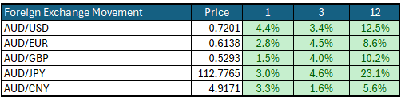

Australian Economy
Australia's latest GDP data for the final quarter of 2025 showed an annual growth rate of 2.6%, up from 2.1% in the third quarter of 2025. Unemployment increased marginally in March to 4.3%, up from 4.2% in February 2026. The year-over-year (Y-O-Y) inflation rate also increased to 4.6%, up from 3.7% in February 2026, and remains outside the Reserve Bank's targeted 2% to 3% inflation range, likely leading to a third rate hike in May.

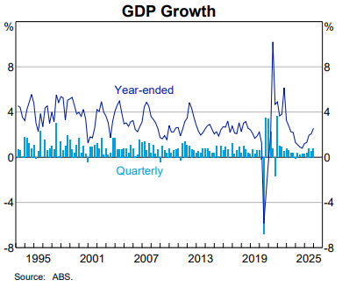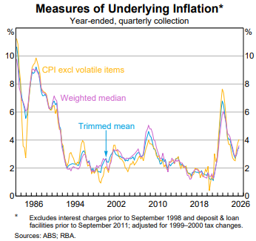

Current Market View

Domestic View
The overall investment view for shares is "cautious" over the short term, "cautiously optimistic" over the medium term, and "long run" as corporate profits continue to grow faster than inflation and as the need to build out data centres drives commodity prices higher.
The market is currently pricing in a full interest rate hike on the 4th/5th of May 2026, due to a "hotter" inflation print in February that showed inflation is now outside the RBA's target range of 2-3%, in combination with increases in the oil price to increase inflation over the short-term.

Global View
The global share market remains cautious, aside from a few AI companies, amid the looming threat of a global inflation spike that could force many economies to raise interest rates. Given the current tensions in the Middle East, globally, we could potentially see a slowdown in GDP as energy production cannot keep up with the rollout of AI datacentres.

Where to From Here?
- Continued shift from rules-based order and win-win multi-lateral trade to power-based order and win-lose trade deals. Trump did not start this. The shift started in the 2010s with the U.S./Europe letting Putin take Crimea in return for cheap gas for Germany/Europe, and the U.S./Japan letting China militarise the South China Sea. It has certainly accelerated under Trump. Lower cross-border trade & investment, more reliance on government subsidies & distortions, and inflationary onshoring of uneconomic industries.
- Sticky inflation - political pressure on central banks to keep rates low – populist pressure on governments to keep deficit spending. Tariffs + onshoring adding to costs/prices. Bond yields to stay elevated or even drift higher, risk of bond yield spikes, or a sudden need for rate hikes, unsettling / breaking share markets.
- Share markets continue to be supported by good profit growth for now. Shares everywhere are expensive, buoyed by loose monetary & fiscal policies and a near-certainty that governments will throw 'free'/borrowed money at any problem.
- Commodities rally gathering pace – rising demand soaking up oversupply, AI/data centre boom (industrial metals, energy, water, land), global rearmament – especially Europe, Japan, Canada. This should support the ASX market, as long as banks avoid a local recession.
- De-dollarisation fears are probably overdone, but are driving up gold and silver, not bitcoin. U.S. Treasury yields are not at risk for now (and even fell in February).
- The current boom will end one day, of course. All markets everywhere, including and especially Australia, are over-priced on fundamentals, not just U.S. big tech. However, each boom is different, and the triggers for the inevitable bust are different each time.

This document is issued by Atlas Funds Management Pty Ltd. Atlas Funds Management Pty Ltd does not provide any general advice or personal advice regarding any potential investment in any financial products within the meaning of section 766B of the Corporations Act. No consideration has been made of any specific person's investment objectives, financial situation or needs. The provision of this presentation is not and should not be considered as a recommendation in relation to an investment in any entity or that an investment in any entity is a suitable investment for any specific person. Recipients should make their own enquiries and evaluations they consider appropriate to determine the suitability of any investment (including their investment objectives, financial situation, and particular needs) and should seek all necessary financial, legal, tax and investment advice. Atlas Funds Management Pty Ltd, it's directors and employees do not accept any liability for the results of any actions taken or not taken on the basis of information in this presentation, or for any negligent misstatements, errors or omissions. This presentation is not an advertisement and is not intended for public use or distribution. Past performance of a fund is no guarantee of its future performance.

